We are off on a Virtual School Visit!
On Friday 12th February, Uplands Manor will be going on a virtual safari!
This will be a whole school event for everyone to enjoy together.
We will be able to travel through the world-famous Longleat Safari Park from our own homes.
Don’t forget to pack some snacks or a picnic!
The virtual safari follows the drive-through route through the Safari Park. We will begin our virtual journey among the giraffes and zebras of the East Africa Reserve before heading off to see camels, ostriches, rhino, antelope, vultures, big cats and many other wild and wonderful animals.
There is a link in this folder to open up your adventure!
After the thrilling safari, choose some of the activities below to show your teachers what you have discovered!
Help your child to make a fact file with amazing facts about one of the animals you have seen on your safari.  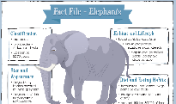 | Make a model of an animal…you could use Lego, plasticine, playdough, junk, building blocks….anything at all. | Draw a picture of one of the animals.  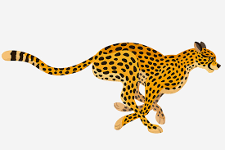  Search YouTube for ‘Draw with Rob’ for some great videos with top tips and ideas of how to draw animals. | Make an animal mask out of an old box.  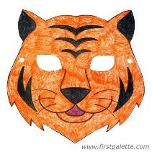
Read or listen to stories about animals…  There are lots online. | 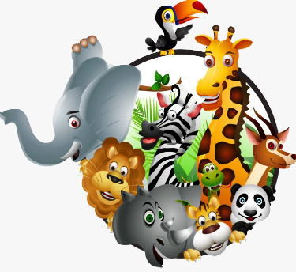 | Make an obstacle course and complete it pretending to be different animals! | Design a safari board game to play with your family… or draw a picture and cut it up to make a jigsaw puzzle.

You can share your work on Twitter @NurseryUMps

